**What is Mode?**

Mode is the most frequently occurring value in a dataset. Along with mean and median, mode is a statistical measure of central tendency in a dataset. Unlike the other measures of central tendency that are unique to a particular dataset, there may be several modes in a dataset.

**Advantages of Using Mode**

In certain cases, mode can be an extremely helpful measure of central tendency. One of its biggest advantages is that it can be applied to any type of data, whereas both the mean and [median](https://corporatefinanceinstitute.com/resources/excel/functions/median-function/) cannot be calculated for nominal data. It is also not affected by extreme values in datasets with [quantitative data](https://corporatefinanceinstitute.com/resources/knowledge/finance/quantitative-analysis/). Thus, it can provide the insights into almost any dataset despite the data distribution.

On the other hand, the statistical measure also comes with its own limitations. For instance, it cannot be further treated mathematically. Therefore, the measure cannot be used for more detailed analysis. In addition, since it is not based on all values in the dataset, it is difficult to draw conclusions regarding the dataset relying on mode only.

**How to Find the Mode**

No calculations are necessary to find the mode. Simply follow the steps below:

1. Collect and organize the data from a dataset.
2. Determine all the distinct values in a dataset.
3. Count the frequency of occurrence for each distinct value.
4. The most frequent value(s) is the mode.

In addition, it can be easily found using the distribution graph or [histogram](https://corporatefinanceinstitute.com/resources/excel/study/histogram/). Graphically, it is represented as the peak point on the distribution graph or the tallest bar on the histogram.

**Example of Mode**

You are the financial analyst at an [e-commerce company](https://corporatefinanceinstitute.com/resources/knowledge/valuation/startup-valuation-metrics-internet/). You’ve been assigned a task to determine the most frequently purchased category of a product in the last month.

In order to complete the task, you retrieve the data of the purchases for the last month. The data is summarized in the table below:

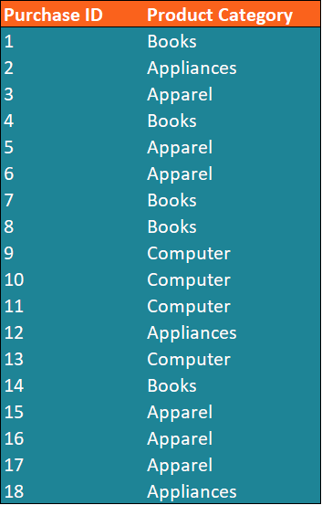

The task can be completed by determining the mode of the product category in the dataset, which can be found using the steps below:

1. Identify the distinct values in the dataset. We can see that the distinct values of the product categories in the dataset include *Apparel, Appliances, Books, and Computer.*
2. 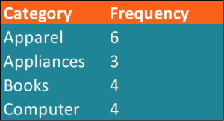Calculate the frequency of each distinct value in the dataset.

1. Determine the mode (the most frequent distinct value).

From the table above, we can see that the apparel category is the most frequent in the dataset. In other words, apparel is the mode in the dataset.

Alternatively, we can find the mode using a histogram (or other frequency distribution chart). Using our original data, we can easily create a histogram in Excel.

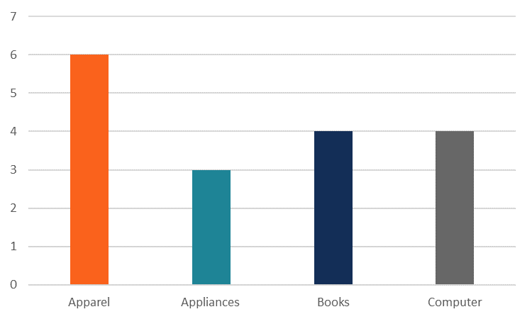

**From the chart, we can clearly see that the apparel category is the mode in the dataset.**

**Example:**  
Find the mode of the following set of scores.  
14 11 15 9 11 15 11 7 13 12

**Solution:**  
The mode is 11 because 11 occurred more times than the other numbers.

If the observations are given in the form of a frequency table, the mode is the value that has the highest frequency.

**Example:**  
Find the mode of the following set of marks.

|  |  |  |  |  |  |
| --- | --- | --- | --- | --- | --- |
| Marks | 1 | 2 | 3 | 4 | 5 |
| Frequency | 6 | 7 | 7 | 5 | 3 |

**Solution:**  
The marks 2 and 3 have the highest frequency. So, the modes are 2 and 3.

**Note:** The above example shows that a set of observations may have more than one mode.